- Open the file survey_test0901 and save it to your Functional skills ICT folder
- Insert a new column in an appropriate location (before the Total Votes column). Call the column Stoke shoppers
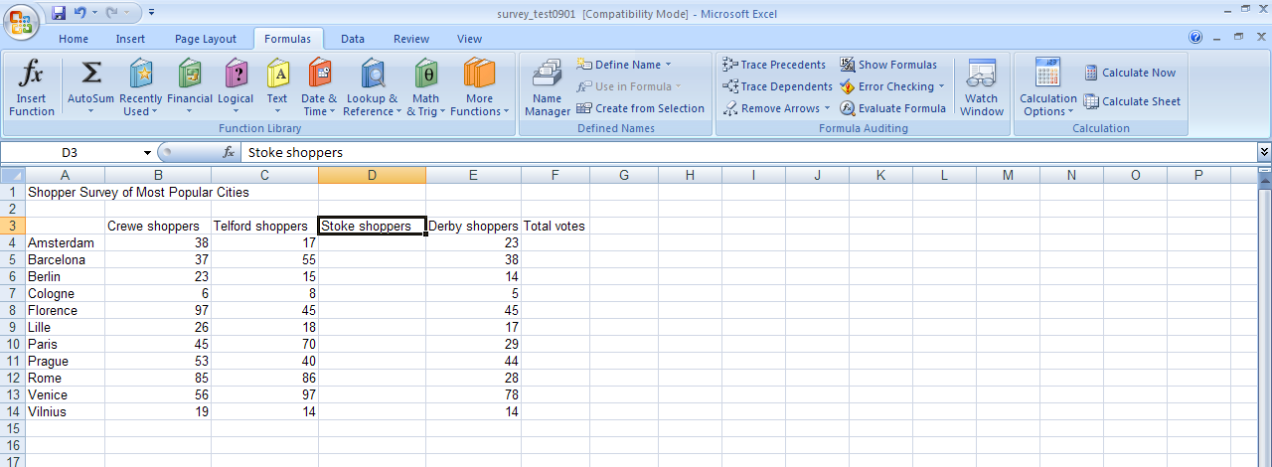
- Insert the votes for Stoke
- Enter a formula in the Total Votes column to calculate the total votes for each city
Example =sum(B6+C6+D6+E6)...how else could you write this?
- Format the spreadsheet to make it easier to read and understand
- Sort the spreadsheet by Total votes with the highest total at the top
- Insert a header with your name, candidate number (BA123654) and centre number (50703)
- Save this with a suitable file name
- Print your spreadsheet in data view (no formulas showing), make sure it fits onto an A4 page, so you may have to change to Landscape view.
- Change the view to show:
  - formulas and insert
  - gridlines
  - all columns, you might have to shorten these
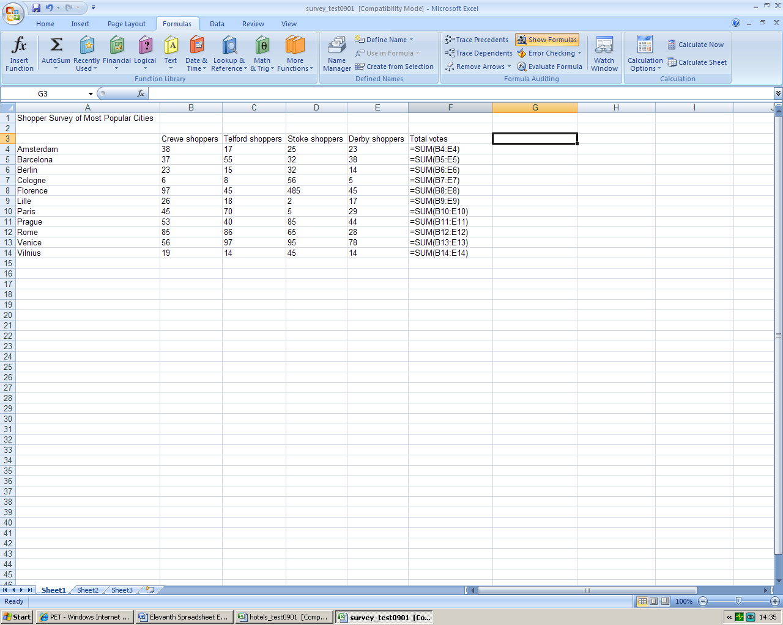
- Create a bar chart that shows the Total Votes and each city, insert this into your spreadsheet
- Save and print

